

Table of Contents

**Making Changes to a Survey** 2

**Coaches Survey** 3

**Survey link:** Qualtrics - Coaches Survey 3

**Scope and Audience** 3

**Current Data Flow** 3

**PAX Survey** 4

**Survey link:** Qualtrics - PAX Survey 4

**Scope and Audience** 4

**Current Data Flow** 4

**End of Pilot Survey** 5

**Survey link:** Qualtrics - End of Pilot Survey 5

**Scope and Audience** 5

**Current Data Flow** 5

# **Making Changes to a Survey**

**Disclaimer:** adding a new question will disrupt the existing connection between the survey and the database. **Please contact the data science team to incorporate a new question into the lambda function and the database.**

Modifying question types in the Qualtrics survey can be done without compromising the integrity of the database connection ONLY IF those same changes are also reflected in the database. For instance, updating an existing question from a text to numeric response, or vice versa.

**\*Note: Survey link URL’s will change once surveys are imported into the BAH environment**

**Links provided below access Qualtrics online *How to Guides* directly**

* [**Qualtrics - Creating, Editing & Formatting Questions**](https://www.qualtrics.com/support/survey-platform/survey-module/editing-questions/creating-questions/)
* [**Qualtrics - Choosing a Question Type**](https://www.qualtrics.com/support/survey-platform/survey-module/editing-questions/question-types-guide/question-types-overview/)
* [**Qualtrics - Additional Question Options**](https://www.qualtrics.com/support/survey-platform/survey-module/question-options/question-options-overview/)
* [**Qualtrics - Distributing Surveys**](https://www.qualtrics.com/support/survey-platform/distributions-module/distributions-overview/)

# **Coaches Survey**

## **Survey link:** [Qualtrics - Coaches Survey](https://nd.qualtrics.com/jfe/form/SV_agd2GnTpeiqKsU5)

## **Scope and Audience**

* Intended for program coaches
* Used to input participant results from a variety of tests including:
  + Elite HRV
  + Blood Work
  + InBody
  + Physical
  + Cognitive
  + Utilization
* The *Coaches Survey* includes 73 questions in total, across 6 separate surveys

## **Current Data Flow**

* Coaches access the survey either on a tablet, desktop/laptop, or cell phone
* The survey may be accessed using the direct Qualtrics link, or using the Qualtrics cell phone application
* All questions are formatted to include a forced response which requires that all fields be completed

**Steps:**

1. Enter a PAX ID
2. Select a survey from the *Table of Contents* (Figure 1) 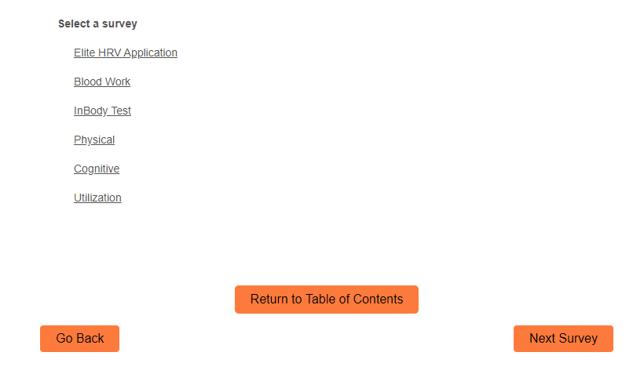
3. At the completion of a survey, the coach can choose between the following options using the orange toggle buttons at the bottom of the survey (Figure 2):
   * **Submit and Finish:** This will complete the survey entry process and push the results through to the database
   * **Table of Contents:** This sends the coach back to the table of contents to choose another survey to complete
   * **> (Advance):** Advances to the next survey based on the order in the table or contents

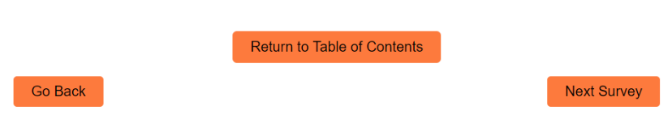

# **PAX Survey**

## **Survey link:** [Qualtrics - PAX Survey](https://nd.qualtrics.com/jfe/form/SV_3xZbfX35E1WrBWJ)

## **Scope and Audience**

* Intended for program participants
* Used by participants to collect lifestyle and health-related information prior to and after the completion of the TAP program. Sections include:
  + Personal
  + Physical Activity
  + Energy (Sleep)
  + Pain
  + Nutritional
* The *PAX Survey* includes 47 questions within 1 survey

## **Current Data Flow**

* Participants access the survey either on a tablet, desktop/laptop, or cell phone
* The survey may be accessed using the direct Qualtrics link, or using the Qualtrics cell phone application
* All questions are formatted to include a forced response which requires that all fields be completed
* Submission of each PAX survey triggers an email to notify coaches of new responses
* Responses from this survey will result in RAG scores displayed in a PowerBI dashboard

**Steps:**

1. Choose *pre* or *post*
2. Select your billet
3. Enter your PAX ID (Provided to participants by their coach)
4. **> (Advance):** Advances to the next portion of the survey until submission

# **End of Pilot Survey**

## **Survey link:** [Qualtrics - End of Pilot Survey](https://nd.qualtrics.com/jfe/form/SV_bpHnHN2hpnbUnw9) (ARR Survey)

## **Scope and Audience**

* Intended for program participants upon the completion of their program
* The purpose of the survey is to get anonymous feedback from participants regarding their satisfaction with the programming and coaches
* The survey consists of 29 open-ended and multiple-choice questions

## **Current Data Flow**

* At the completion of programming, participants receive a link to *End of Pilot* online survey
* No PAX ID or identifiable information is collected from participants to preserve anonymity
* Only multiple-choice questions require a response, open-ended questions are response optional